ANOVA

Yijklm= µ + αi + βj + ɼk + ɳl + ƥm + ƛn + ɛijklm

Where αi = effect of Bilirubi

βj = effect of Albumin

ɼk = effect of Urine Copper

ɳl = effect of Alkaline Phosphatase

ƥm = effect if m-th level of Treatment m=1, 2

ƛn = effect of n-th level of Histologic Stage n=1, 2, 3, 4

ɛijklm iidN(0,ơ2)

Global Hypothesis testing:

Ho: αi = βj = ɼk = ɳl = ƥm = ƛn = 0

Ha: ANOVA model is overall significant

The p-value (< 0.001) is small, therefore the overall model is significant. Every factor has a significant effect on the survival time, except for treatment.

Assumptions:

1. Constancy of variance

By looking at the residuals vs. predicted value graph, we conclude that the constancy of variance is obtained.

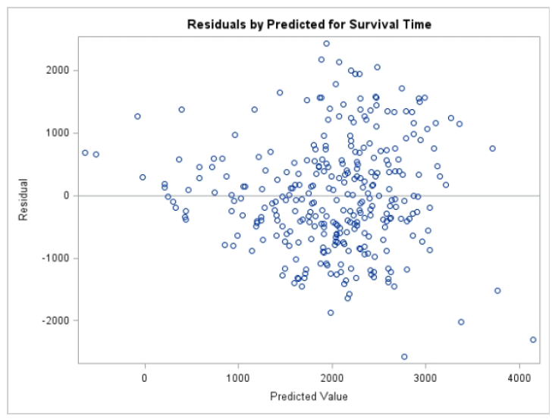

1. Normality test for residuals

By looking at the p-p plot graph, we conclude that the residuals follow a normal distribution with a few outliers.

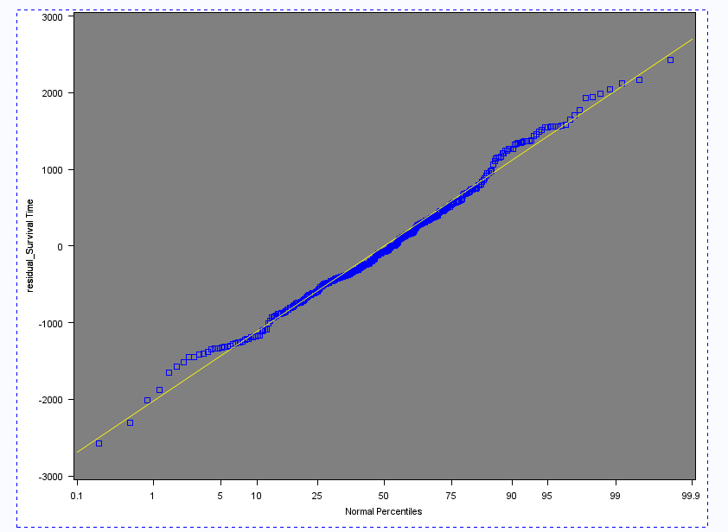

Ho: Residuals are normally distributed

Ha: Residuals are not normally distributed

The Kolmogorov-Smirnov, Cramer-von Mises and Anderson-Darling test report p-values >.15,0.061,0.034. At α = 0.01, the p-values are large, so this supports Ho. At α = 0.05, the Anderson Darling has a small p-value, so we reject Ho.